SURFACE MIX BURNER GROUP L-14 Linear Burner
......Machine Mounting...... Range: SMDJ
Rectangular Flame Matrix.
Surface Mix.
Oxygen-Gas.
50 - 200 Flame Length x 2 Row
Typical glass industry applications include:
Fire - Flame Polishing and Edge/Rim glazing
of all tabletop and beer glasses.
Various shaping, forming and annealing
operations during the secondary heating of
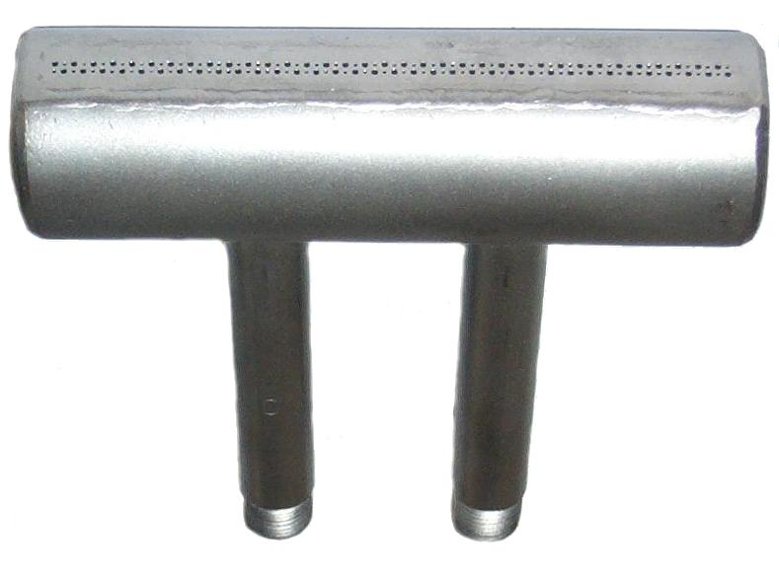
glass articles, containers and components.

Supply pressure requirements.
Natural gas: 20 - 1000 mbar
Propane gas: 20 - 1000 mbar
Hydrogen: 350 - 1000 mbar For Hard glass working.

Oxygen: 1 - 4 bar

Cat.No. Type. A B C D - Inlet Size. kW/hr.
L350 SMDJ-50 50 57 25 1/8”BSP 9.95
L351 SMDJ-75 75 82 40 1/8”BSP 14.90
L352 SMDJ-100 100 107 50 1/8”BSP 19.50
L353 SMDJ-150 150 157 75 ¼”BSP 29.50
L354 SMDJ-200 200 207 100 ¼”BSP 39.30
Gas and Oxygen flow control valves are available as an optional extra.
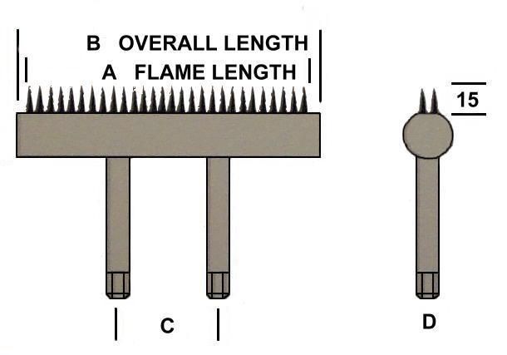

To avoid burner face sooting, liquified natural gas [lng] and propane may need a small injection of process air into the burner gas feed. Partial pre-mixing the fuel gas with oxygen will significantly increase the heat transfer rate. The Rapidflame technical department will assist and advise on the selection and positioning of venturi mixers and flow control valves.
Gas burners and combustion equipment must be installed and used in compliance with all relevant applicable regulations and industry codes of practice.

The Rapidflame policy is one of continuous development and improvement, we therefore reserve the right to change any specification or design without prior notice.

