SURFACE MIX BURNER GROUP L-6 rev. Linear Burner
.....Machine Mount...... Range: SMSR (1 to 6 rows)
Rectangular Flame Matrix
Surface Mix
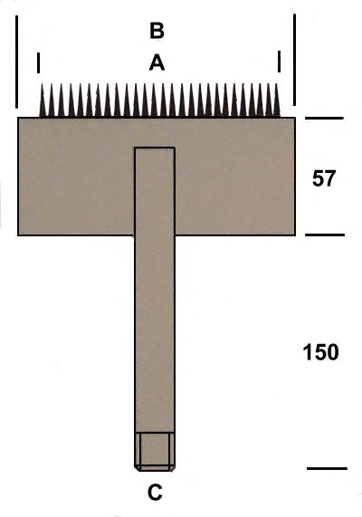
Oxygen-Gas
3 ROW......4 ROW
5 ROW......6 ROW

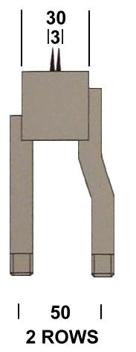
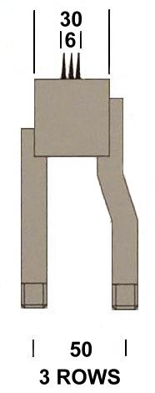
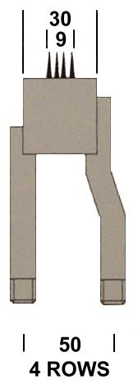
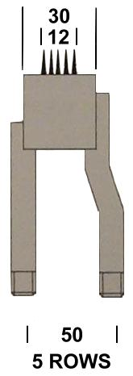
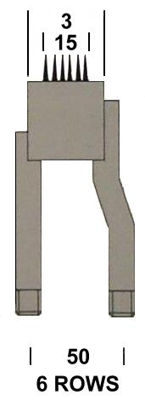

3 ROW 4 ROW
Cat. No. Type. A B C kWh. Cat. No. Type. A B C kWh.
L070 SMSR-3-25 25 45 1/8” 7.90 L085 SMSR-4-25 25 45 ¼” 10.46
L071 SMSR-3-30 30 50 1/8” 9.60 L086 SMSR-4-30 30 50 ¼” 13.00
L072 SMSR-3-40 40 60 ¼” 12.30 L087 SMSR-4-40 40 60 ¼” 16.50
L073 SMSR-3-50 50 70 ¼” 16.00 L088 SMSR-4-50 50 70 ¼” 21.00
L074 SMSR-3-75 75 95 ¼” 23.00 L089 SMSR-4-75 75 95 ¼” 30.00
L075 SMSR-3-100 100 120 ¼” 30.00 L090 SMSR-4-100 100 120 3/8” 40.00
L076 SMSR-3-125 125 145 3/8” 38.00 L091 SMSR-4-125 125 145 3/8” 50.00
L077 SMSR-3-150 150 170 3/8” 45.00 L092 SMSR-4-150 150 170 3/8” 60.00
L078 SMSR-3-175 175 195 3/8” 52.00 L093 SMSR-4-175 175 195 ½” 70.00
L079 SMSR-3-200 200 220 3/8” 60.00 L094 SMSR-4-200 200 220 ½” 80.00
L080 SMSR-3-225 225 245 3/8” 67.00 L095 SMSR-4-225 225 245 ½” 90.00
L081 SMSR-3-250 250 270 ½” 74.00 L096 SMSR-4-250 250 270 ½” 98.00
5 ROW 6 ROW
Cat. No. Type. A B C kWh. Cat. No. Type. A B C kWh.
L100 SMSR-5 25 25 45 ¼” 13.00 L115 SMSR-6 25 25 45 ¼” 15.80
L101 SMSR-5-30 30 50 ¼” 16.00 L116 SMSR-6-30 30 50 ¼” 19.20
L102 SMSR-5-40 40 60 ¼” 20.00 L117 SMSR-6-40 40 60 ¼” 25.00
L103 SMSR-5-50 50 70 ¼” 27.00 L118 SMSR-6-50 50 70 3/8” 32.00
L104 SMSR-5-75 75 95 3/8” 38.00 L119 SMSR-6-75 75 95 3/8” 46.00
L105 SMSR-5-100 100 120 3/8” 50.00 L120 SMSR-6-100 100 120 3/8” 60.00
L106 SMSR-5-125 125 145 ½” 63.00 L121 SMSR-6-125 125 145 ½” 75.00
L107 SMSR-5-150 150 170 ½” 75.00 L122 SMSR-6-150 150 170 ½” 90.00
L108 SMSR-5-175 175 195 ½” 86.00 L123 SMSR-6-175 175 195 ½” 104.00
L109 SMSR-5-200 200 220 ½” 100.00 L124 SMSR-6-200 200 220 ½” 120.00
L110 SMSR-5-225 225 245 ½” 111.00 L125 SMSR-6-225 225 245 ½” 133.00
L111 SMSR-5-250 250 270 ½” 123.00 L126 SMSR-6-250 250 270 ½” 148.00

The Rapidflame policy is one of continuous development and improvement, we therefore reserve the right to change any specification or design without prior notice.

